Client proposed solution:



Pros:

1. Sending data to the computer on the bus stop through BLE requires less fixed cost on the client side. (i.e. no LTE module requires for the bus stop).

Cons:

1. Using user’s phone to receive data from the server means more internet charge and draining battery power on the user side. Bad for user experience.
2. Might require BLE modules on the computers, means more fixed cost.
3. COSC team is not familiar with sending data to computers through BLE. Therefore, it might require significantly more time and does not guarantee the project will be finished on time.
4. Using both GPS and beacon on the bus are overkill. Only one of them should be used. Using separate GPS module also increases fixed cost.
5. The computers on the bus and at the bus stations receive data from the server in two different ways (BLE and LTE). Means more complexity and development time for both COSC and EE teams.

COSC Team Proposed Solution:

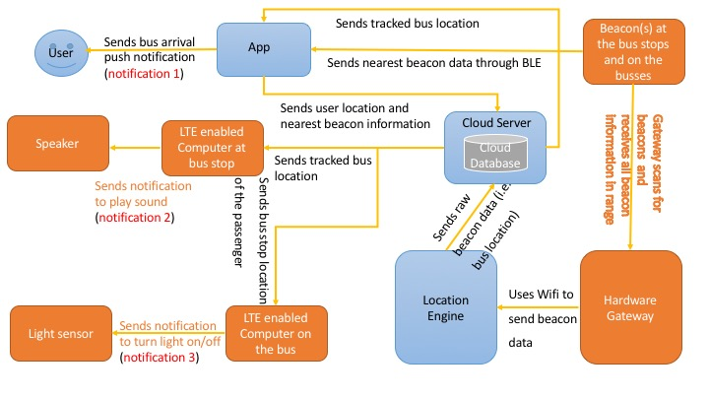

Note: EE team is responsible for the orange parts including receiving data from the server as that is part of small board computer programming. COSC team is responsible for the rest and the server side will do most of the heavy lifting computations.

Pros:

1. Data is going to the end user (app/computers) directly from the server through internet. User’s phone not being the middle man means more battery and internet saving for the user.
2. COSC team knows how to pass data from the server to the computers using internet. We will use industry standard REST API that can be used for iOS or any other platforms as well. COSC team can also guide EE team on how to receive the data from the server, means less development time for both teams and can guarantee a successful project if everything goes well.
3. No extra BLE or GPS modules required. Client saves more money.
4. Minimum API calls made to the server side, means less variable cost.

Cons:

1. LTE modules required for computers on the bus stop and bus both. More fixed cost for the client.

Alternative Solution: Not using beacons at all. Just rely on GPS to get bus location.